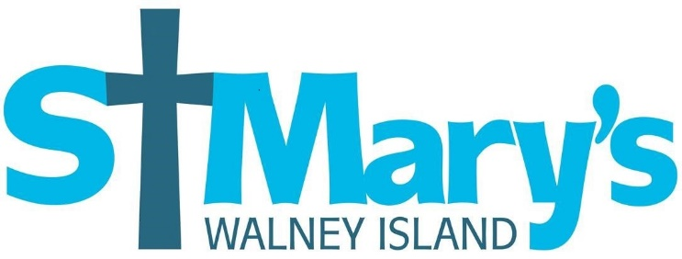

Christening Policy – St Mary the Virgin, Walney Island April 2017

The Parish Church of St Mary the Virgin, Walney is delighted that you are considering christening, whether it is for yourself or your child. St Mary’s welcomes the baptism (also known as christening) of infants and children as well as for adults and is committed to providing a place of welcome and hospitality in which those coming forward for christening, together with parents and godparents can explore and grow in the Christian faith and remain faithful to their promises. Christening is a recognition that you want the best start in life for your child and it is an opportunity for them, as well as family and friends, to receive God’s blessing and begin a lifelong relationship with him.

Initial enquiries should be made at the Parish Evening – on Tuesdays between 6.30pm and 7.00pm at the church. Crèche facilities are available should you need them. At this meeting, you can meet with the Vicar, or if the Vicar is unavailable, the Church Warden, to discuss potential dates for the christening, and to arrange the date of a preparation evening. You will be asked to fill in the necessary application form.

You will be expected to attend a short informal preparation evening, where we will explain how we as a church can support you, and the order of service will be outlined so that it will be familiar to you on the day. Godparents are also warmly invited but we recognise that it may not always be possible for godparents to attend. Often, the preparation session may include other families who are booked in for christenings in the same month.
Residents of Walney Island are welcome to arrange a christening at St Mary’s, and as we have an agreement across all the Anglican churches of Barrow, this welcome is extended to all who live in the Town of Barrow in Furness.

If you live further afield but have a particular reason for wanting your child to be baptised at St Mary’s, then please talk to the Vicar, who may need to contact your local parish as a courtesy.
St Mary’s has historically been a very popular church for christenings, and we currently conduct over 50 each year. We hold services two Sundays a month, the first Sunday is a dedicated service outside of our normal services of worship, and takes place in the afternoon.
We also include christening in our 10am service on the fourth Sunday of the month, which is a lively and accessible service. In exceptional circumstances, additional services may be added by arrangement with the vicar. We book no more than two families for each service.
We will always do our best to find a date that is mutually acceptable, however you may need to arrange this date some months in advance. Please do not arrange a venue for a reception until you have confirmed a date with the church!
There is no requirement for parents of a child to be christened to be baptised themselves, however if you also wish to be baptised at the same service as your child we will be happy to arrange this. We limit the number of godparents to a maximum of six.
We do require Godparents to be baptised, however if there is a particular friend or relative who you wish to be part of the service, and they are not christened, they can be included as supporting friends.

There is no fee for a christening service, but we do take up a collection at our 10.00am service, and there is an offering plate at the back of church for the afternoon service. We ask that you consider making a financial donation to enable us to maintain the many services we provide to the local community.

At the christening service, we will be recognising and celebrating three things:

- Firstly, thanking God for the safe arrival of your child, and the blessing they are to their family.
- Secondly, marking the beginning of a journey of faith for your child, which they can embrace for themselves when they are old enough.
- Thirdly, welcoming the child into the family of God who will always be here to welcome and support them.

During the service parents and godparents will make promises on behalf of the child and commit to help them to learn about Jesus and what being his follower means in the world today. The church family of St Mary’s will always welcome you to any of our services and events and will support you however we can to help your child grow spiritually just as they grow physically. We do hope that you will want to explore some of the opportunities we offer to learn more about the Christian faith, which include a lively toddler group, a regular Sunday School, and the ever popular ‘Messy Church’. We also aim to make our regular services of worship accessible and engaging to families.

The Church is aware that there are many adults who were not christened as children. Often adults in this situation will feel like they have missed their chance for christening. St Mary’s would like to reassure you that we are happy to christen adults and these are joyful and wonderful occasions. Christenings may take place during the main Sunday morning worship or at another suitable time. Christening preparation for adults is tailored to meet the needs of the individual.
Many people feel they would like to give thanks for their child in Church in a very special way, to seek God’s blessings for their child and mark the occasion with a family celebration. For some people, however, christening can feel like it is too big a commitment which they are not yet ready to make. In this case, parents may like to consider a special service of Thanksgiving and Blessing. This is a shorter service without the water or the promises of christening. For more details, please speak to the Vicar.

